**System and Integration Testing**

**The Unit Name:** Integration of R and MySql database in server

**Participants:** Temirlan Bayeshov

**Pass/Fail criteria:** R scripts will be used to test if we can connect to MySql and retrieve data from tables which stored in our server. Firstly we will create connectionResult function for connection to database and test it if our two modules connected successfully. We will use two methods for integration testing: isIdcurrent and dbIsValid. First method will show use if currently we connected to database while second one will show if our database valid. If both of the methods return TRUE than test successfully passed, otherwise in case of FALSE test will be failed. We expect that methods will return TRUE for both methods. After passing this criteria we will check if our data retrieved successfully.

**Results:** We obtained pass for integration test. Both of methods which checks connection to database throw R code showed successful results. We obtained that we can connect to our MySql database on our server, so now we will be able to retrieve data from server.

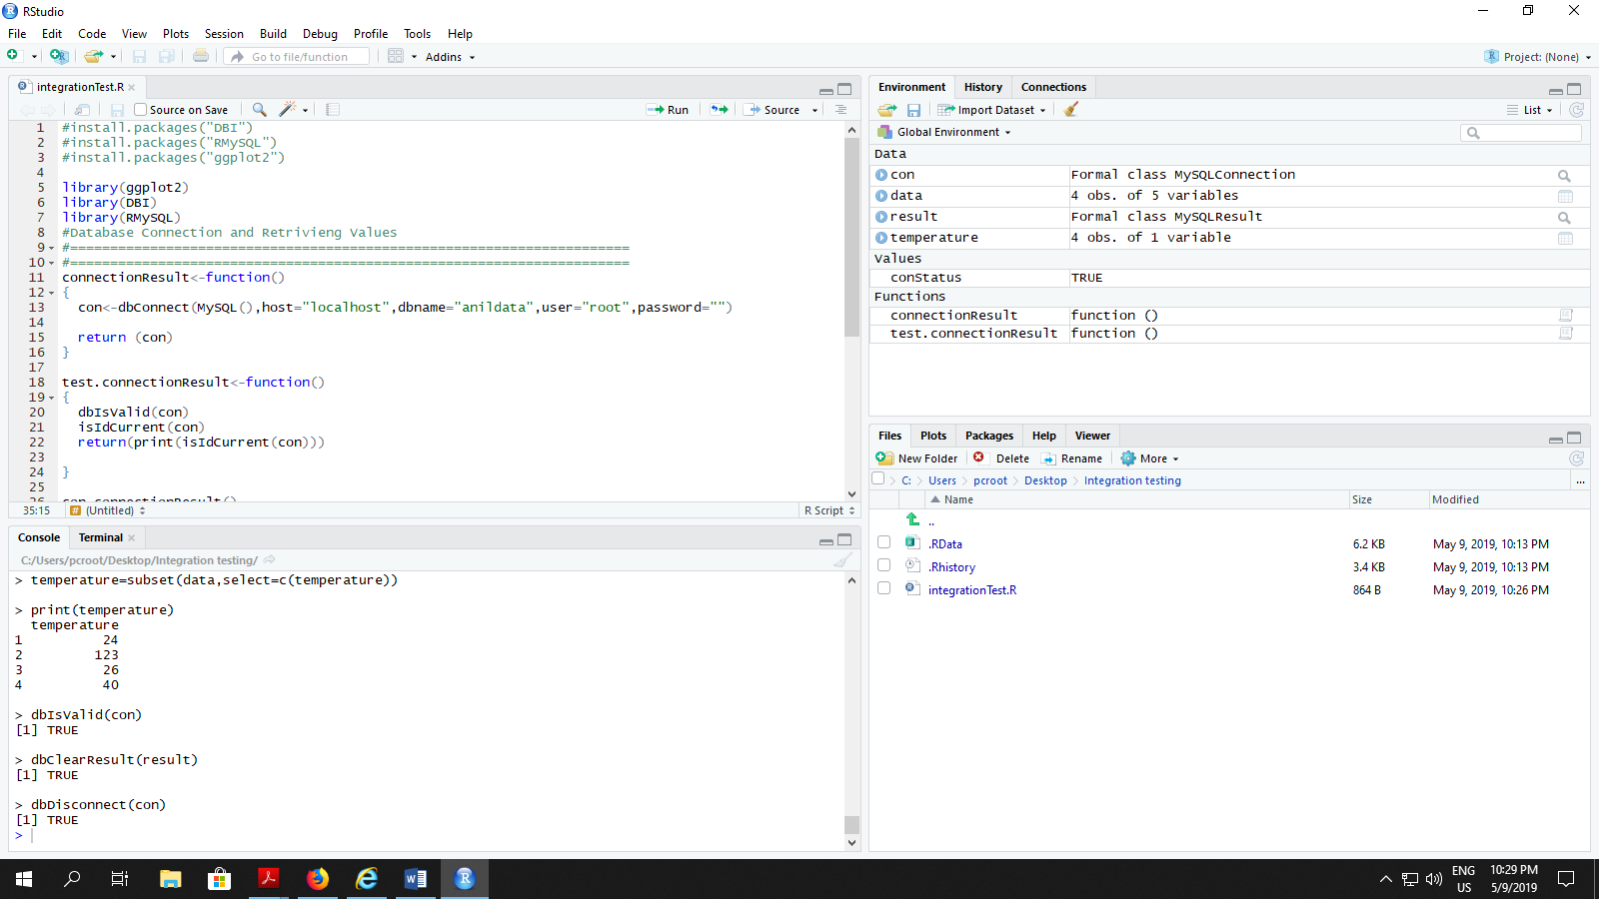

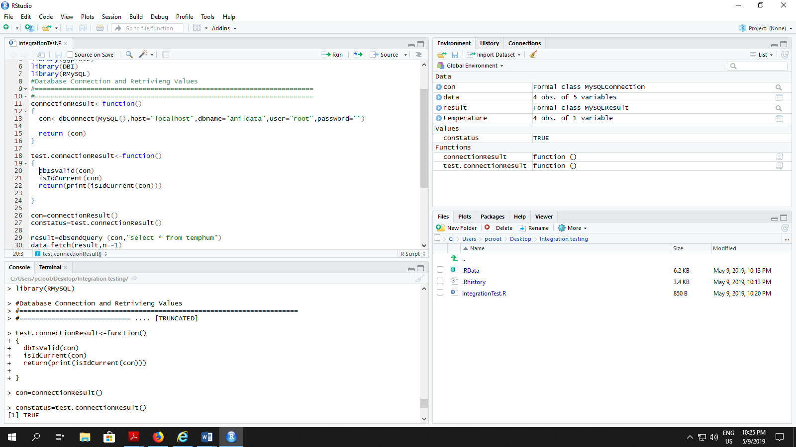

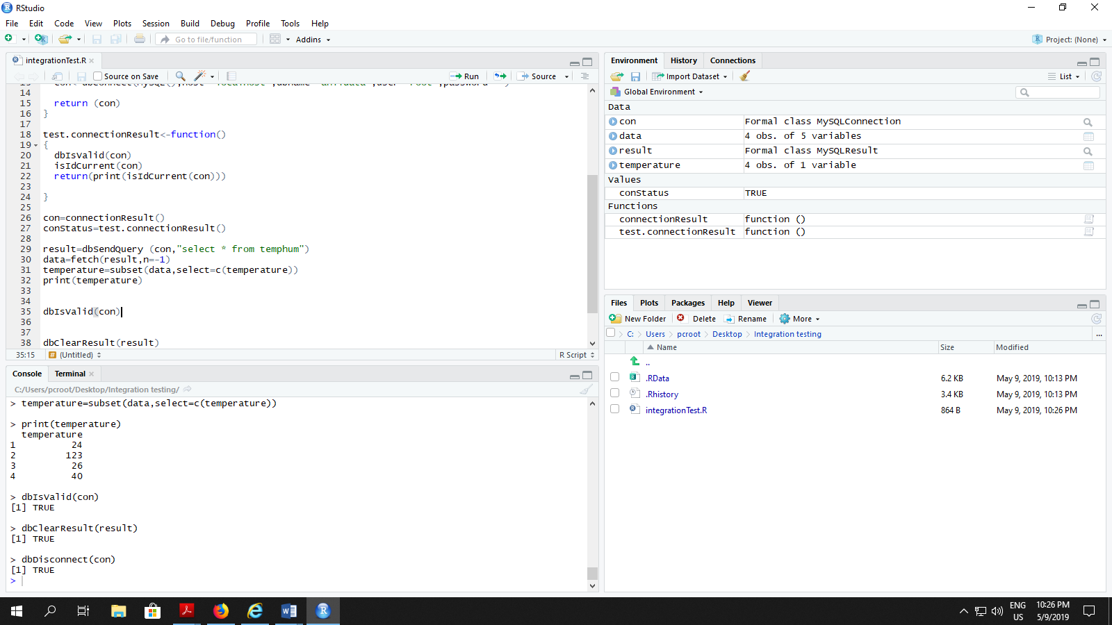

**The Unit Name:** System testing retrieving of data from server

**Participants:** Temirlan Bayeshov

**Pass/Fail criteria:** R scripts will be used for testing if our data will be successfully retrieved from database. After successful integration test of connection to database, we are able to test if we can take data sets from it. We will use test.dataRetrieveResult function to test if we can access to temperature/humidity, etc. values. If we will obtain values we will be able to see them in print method as a table. Otherwise, in case of fail, we will get an error message.

**Results:** After first passed integration test which are connection to database module, we tested if we can retrieve data sets from MySql database. Our test passed successfully without any error messages. Now we able to connect and take a data for next steps of statistical performance.

